**Crystal Jhayne A. Collado BSIT 1-D Computer Organization (COC 101)**

**THE COMPUTER LEVEL HIERARCHY**

The Computer System Level Hierarchy refers to the arrangement of various levels that facilitate communication between the user and the computer. It also illustrates all the components utilized at various system levels and explains how computational tasks are carried out on computers.

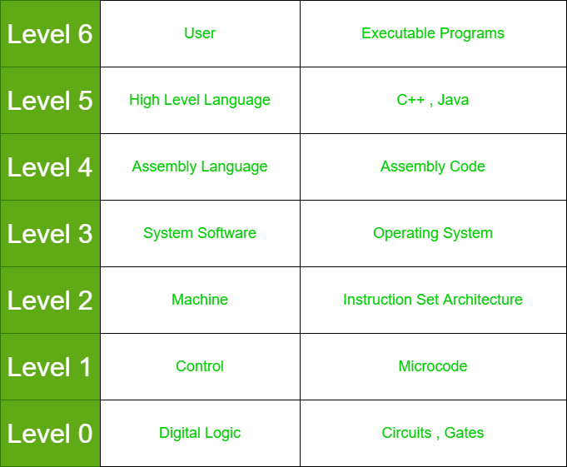There are seven levels in the computer system level hierarchy:

* **Level 0:**

Digital logic is connected to it. Digital logic serves as the foundation for digital computing and offers a fundamental understanding of the communication between circuits and hardware in a computer. It is made up of different gates and circuits, etc. These are the basic components of all computer systems, the ways in which mathematical reasoning is implemented.

* **Level 1:**

Control is connected to this level. The system's control level is where microcode is utilized. The computer system at this level includes control units.

* **Level 2:**

There are machines on this level. The computer system uses many kinds of hardware to carry out various kinds of tasks. Instruction set architecture is present in it. On a hardwired computer, programs written in the actual machine language of the computer can be run directly by the electronic circuits without the need of interpreters, translators, or compilers.

* **Level 3:**

At this level, system software is present. There are several kinds of system software. System software primarily facilitates process operation and creates the link between the user interface and hardware. It could include library code, the operating system, etc. This level is responsible for multiprogramming, protecting memory, synchronizing processes, and various other important functions. Often, instructions translated from assembly language to machine language are passed through this level unmodified.

* **Level 4:**

The next level of the computer system is called assembly language. Since the computer can only understand assembly language, all high-level languages must be translated into assembly language in order for it to function. For it, assembly code is written. This is a one-to-one translation, meaning that one assembly language instruction is translated to exactly one machine language instruction.

* **Level 5:**

High-level language is present at this system level. C++, Java, FORTRAN, and numerous other languages are examples of high-level languages. The command is given by the user in this language. These languages need to be converted into a language that the computer can understand (either by using an interpreter or a compiler). Machine code is created by assembling compiled languages into assembly languages. The user at this level sees relatively little of the lower levels (they are translated to the next lower level). A programmer does not necessarily need to understand how data types are implemented, even though he or she must be aware of them and the commands that can be used with them.

* **Level 6:**

The most familiar level for everyone is the user level, which consists of programs. We can operate word processors, graphical applications, and games at this level.